**HAZARDOUS AREA MONITORING FOR**

# INDUSTRIAL PLANTS POWERED BY IOT

**SUBMITTED BY**

**MEENA S (620319106035)**

**GAYATHRI S (620319106023)**

**MOULISHA R (620319106037)**

**RITHIKA B (620319106047)**

# BACHELOR OF ENGINEERING ELECTRONICS AND COMMUNICATION ENGINEERING

**BLOCK DIAGRAM :**

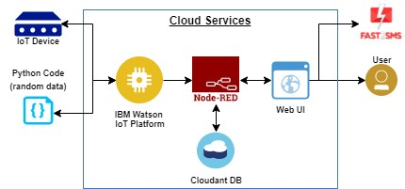

**ARCHITECTURE :**

* Through this, we can monitor the temperature parameters of the hazardous areas in industrial plants.
* The area is integrated with smart beacon devices which will be broadcasting the temperature of that particular area.
* Every person working in those areas will be given smart wearable devices which will be acting as beacon scanners.
* Whenever the person goes near the beacon scanners he can view the temperature on his wearable device and if the temperature is high, he will receive the alerts to the mobile through SMS using API.
* Through this wearable device, the data is sent to the cloud and through the dashboard, the admins of that particular plant can view the data and take necessary precautions if required.